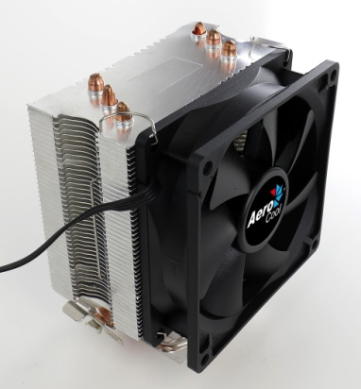
Product Overview:
Comes with 3 ultra-efficient thermal heat pipes. PWM air cooling solution powered by Heat Core Touch Technology (HCTT) and equipped with high efficiency fins. Compatible with most current motherboard designs.
Specifications

Model |  | Verkho 3
Base Material |  | Aluminum block with HCTT Heat Core Touch Technology
Fin Material |  | Aluminum
Heat pipe |  | 6mm x 3
Dimension |  | 120 x 81 x 122.5mm
TDP(Thermal Design Power) |  | 120
Fan | Speed | 1200-2800 rpm
 | Connector | PWM 4-Pin
 | Dimension | 90 x 90 x 25mm
 | Bearing Type | Hydraulic Bearing
 | Started Voltage | 5V
 | Rated Voltage | 12V
 | Rated Current | 0.2 A
 | Power Consumption | 2.4 Watts
 | Air Pressure | 0.548-1.24 mm-H2O
 | Air Flow | 18.9-45.5 CFM
 | Noise | 15-24 dBA
 | MTBF  (Mean Time Before Failure) | 60000 hrs.
Socket |  | LGA 1156/1155/1151/1150/775 AM4/AM3+/AM3/AM2+/AM2/FM2/FM1

Warranty

1 year

Features

- TDP (Thermal Design Power) up to 120W.
- Compact side flow air cooler for maximum compatibility.
- Heat Core Touch Technology and 3 ultra-efficient thermal heat pipes.
- Upgraded high efficiency fins for optimal thermal performance.
- Ultra-slim profile capable of mounting single 90mm fan configurations; works with most current motherboard designs.

Package Information

Product Name | Product Number | EAN CODE | UPC CODE
Verkho 3
Carton Size ( L x W x H ) | 425 x 330 x 365 mm | Carton Weight
Retail Box Size ( L x W x H ) | 135 x 104 x 175 mm | Retail Box Weight
Carton Qty | 18 pcs | Pallet Qty

